Radevormwald, April 2023

High quality plastic parts from Erlemann & Huckenbeck
Your expert for processing thermoset and thermoplastic moulding compounds

A cornerstone of the Erlemann & Huckenbeck range of services are thermoset and thermoplastic parts, which are manufactured according to drawings using injection moulding or compression moulding processes. For both segments, the company draws on extensive know-how which, for customers is reflected in high-quality, highly functional components. The key products include grips, knobs, knurled screws, handwheels and sealing clips.

Based on their strength, high heat resistance (self-extinguishing) and good creep resistance, thermoset components find use in sectors such as automotive, materials handling and machine construction. Due to their high chemical resistance to acids, alkalis and solvents and their abrasion and dimensional stability, they are also popular in the medical sector. The surface finish is also often high-gloss, making them easy to clean. Thermosets can be divided into three different types: free-flowing materials, bulk moulding compounds (BMC) and sheet moulding compounds (SMC), with free-flowing thermosets making up the widest application field.
Thermoplastics are easier to mould and shape due to the lower melting point, so they offer a certain degree of flexibility. Thermoplastics are also durable and chemically resistant, but unlike thermoset plastics, they can be melted and recycled multiple times, making them a more sustainable choice. Some thermoplastics such as polycarbonate and acrylic are also transparent, making them ideal for applications such as windows, lenses and screens.
Manufacturing processes and applications
Erlemann & Huckenbeck manufactures thermoset parts with a compression moulding process using its own in-house manufactured compression moulds - a special competence and unique characteristic of the company. The respective thermoset (free-flowing, BMC, SMC) is poured cold or slightly preheated into the vertical opening of the mould which has a working temperature of between 130 and 150 °C. As soon as the thermoset material hits the mould, a thermal reaction begins: the raw material becomes liquid and starts to homogenise. Parallel to this process, the press is closed so that the material is evenly distributed in the cavity and hardens. The part (e.g. a housing or cover of an intercom for railway stations) is then ground and polished as required.
By injection moulding processes used for thermoplastic, the E&H moulds are opened horizontally. Dry thermoplastic is mixed in a hopper with additives such as colour, UV or combustion stabiliser and homogenised in the injection unit. It is then injected into the much cooler mould, filling the mould cavities. After the subsequent hardening time, the finished components such as sealing clamps or rollers can be removed.

(Characters including spaces: 3,056)

About Erlemann & Huckenbeck
Founded in 1936 by Ernst Erlemann and Walter Huckenbeck, Erlemann & Huckenbeck is today an expert for high-quality technical moulded parts and grips made of thermosetting and thermoplastic materials, which are produced by compression and injection moulding. High precision, great stability and durability are the hallmarks of the operating parts made by the company. With its own tool and mould making department and a high level of vertical integration at its German location, Erlemann & Huckenbeck enjoys high flexibility for the series production of customer-specific solutions.
At the company headquarters in Radevormwald, around 40 employees work on more than 50 plastics processing production machines.

Image overview:

Image 1:
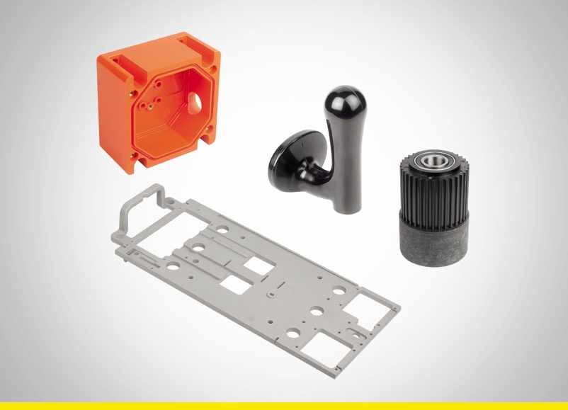
Mounting plates, crates, dispensing taps and toothed washers made of thermoset are manufactured using the compression moulding process.
Image: Erlemann + Huckenbeck

Image 2:

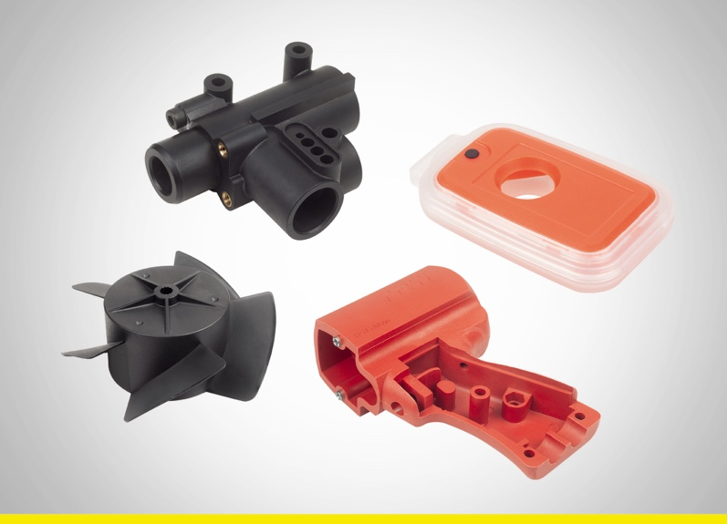
Suction housing, dosimeter, fan wheel and pistol body made of thermoplastic are manufactured by injection moulding.
Image: Erlemann + Huckenbeck

Meta-Title: Erlemann & Huckenbeck produce high quality plastic parts

Meta-Description: Erlemann & Huckenbeck is an experte for processing thermoset and thermoplastic moulding compounds

Deeplinks:
https://erlemann-huckenbeck.de/
https://erlemann-huckenbeck.de/produkte/bedienteile/
https://erlemann-huckenbeck.de/leistungen/werkzeugbau/

Keywords: Erlemann & Huckenbeck, thermoplastic, thermoset, plastic parts, operating element moulded parts, tool making, compression moulding, injection moulding

Download-Area: https://erlemann-huckenbeck.de/unternehmen/download/

Erlemann & Huckenbeck GmbH & Co KG
Adriana Klink
Elberfelder Strasse 122
D-42477 Radevormwald
Telephone: +49-2195-9125-0
Fax: +49-2195-9125-50
Email: info@erlemann-huckenbeck.de

Press office:
Köhler + Partner GmbH
Brauerstrasse 42 • 21244 Buchholz i.d.N.
Telephone +49 4181 92892-0 • Fax +49 4181 92892-55
info@koehler-partner.de • www.koehler-partner.de

